THE QI JOURNEY EXPLAINED

The QI Journey, devised by NHS Education for Scotland, shows the domains which comprise an improvement initiative or project. There are six stages of the process, and three generic domains which run throughout all stages of a project. This guide gives more detail into each domain and lists tools and approaches that will be most helpful. In reality, your QI journey is unlikely to be linear. You will move back as well as forward, and will likely need to work on different aspects at the same time and throughout your project. Click on the links below to read more directly from the QI Journey webpage.

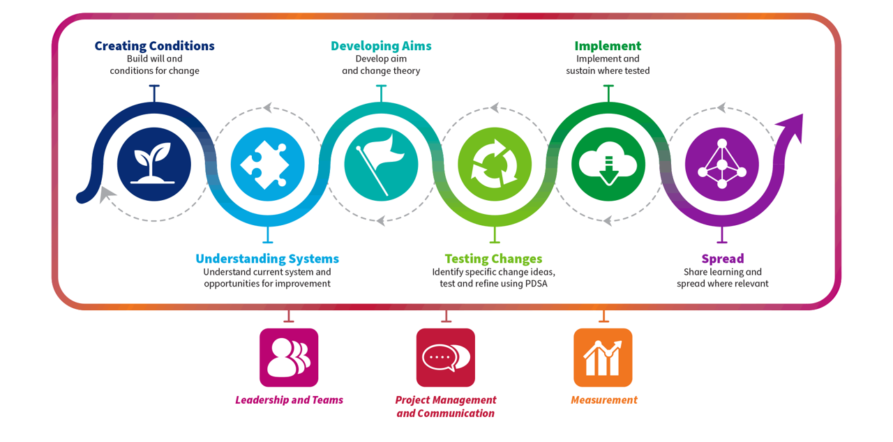

Domain | What does this mean? | Examples  NB., you should also evidence education in these domains. See RCEM QI page for a range of resources
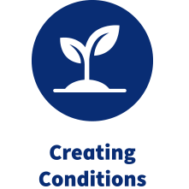 | Creating Conditions At the outset of a QI project, it’s essential to make the case for change. Define the problem. What will success look like in this QI project? Key people should be considered: start putting together a project team and establish a coalition of senior sponsors who will be able to facilitate and champion the project | - Patient stories  - Serious incident
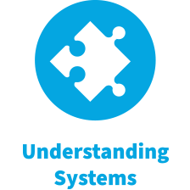 | Understanding Systems This domain describes structured analyses of the landscape. What is the system in question? Is it the whole ED? The waiting room? Patients with sepsis?  What is people’s experience? What do staff think? What are the barriers they face? What do patients think?  This domain also includes analysis of system flow and human factors and ergonomics | - Initial baseline audit  - Process map  - Cause & Effect analysis  - Fishbone diagram  - Stakeholder analysis  - Forcefield analysis  - Staff surveys or focus groups  - Patient surveys or focus groups  - Pareto charts
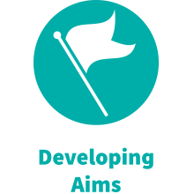 | Developing Aims As the project is taking shape, and shifting from analysis and understanding the problem towards planning changes, a clear aim must be defined. This will be informed by the baseline analysis and should be structured.  QI methodology should also be determined at this stage | - SMART aim  - Statement of QI methodology
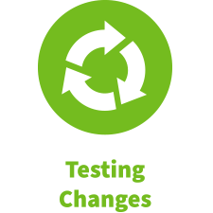 | Testing Changes Once the system and the problems affecting are analysed and better understood, it’s then important to generate change ideas and make plans to implement and test them out.  Change ideas, a.k.a. interventions, are the building blocks to drive improvement. These should be planned and put into action as early as possible in the process. | - Benchmarking (testing against evidence-based standards)  - Innovation (using creativity to generate new ideas and then testing them out)  - Driver diagram  - EAST framework  - Brainstorming  - PDSA cycle
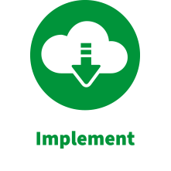 | Implement Now that the PDSA cycles have been designed, they should be put into action. Consider implementing more than one change in parallel vs sequential.  How will improvement be sustained once the change ideas are launched?  A key component of bringing about improvement is behaviour change. How can this be achieved? What are the barriers to behaviour change? | - PDSA cycle  - Standards / guidelines / SOP  - Training / teaching / induction  - Run / SPC chart (continuous measurement)  - What’s In It For Me? tool  - Behavioural science / Nudge Theory  - EAST framework
 | Spread This describes scaling-up of the project, and sharing and disseminating the key messages from the journey you have been on  Consider whether the project may be scaled up: what is the next stage?  How will you disseminate learning from the QI project? Will it be applicable to other departments, other systems? | - IHI Readiness for Spread checklist  - Presentation at local / regional QI day  - Presentation / poster at conference  - Publication in peer-review journal / online

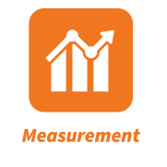 | Measurement Measurement and data are central to Quality Improvement. Data is necessary to understand the problem and then make the case for change (baseline measurement / analysis), to track your progress over time, to test PDSAs, and to tell the story of the project.  Data does not need to be large volume and statistically rigorous as in research. Qualitative data eg., feedback, patient stories, is also valid and often powerful.  When designing the project it’s important to determine your measures in advance. When implementing the project, measurement must continue in parallel with a simple data collection plan. This should then be represented in such a way that tells the story of the project, taking into account natural variation. | - Your role in data collection & representation (if not leading on a project)  - Outcome / process / balancing measures  - Run charts / SPC charts  - Qualitative and quantitative data  - Repeated sampling and several data points  - Representation of data in simple visual formats for eg., posters, presentations
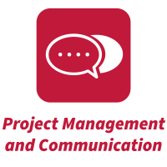 | Project Management and Communication This is the ‘engine room’ of the QI project. A plan and framework for how the project is run, is needed to ensure that it moves forward and achieves its aims in a timely fashion.  The project should be defined at the outset and a plan written to define the change ideas. The team must be clear about the shared vision for the project, and have regular check-ins  Once the project has started, there must be regular communication between all team members: to update on progress of their tasks, share findings and data, flag up any issues and to maintain momentum. Consider what channels of communication the team should use (possibly more than one).  Communication should not just be confined to within the team. The team must ‘bang the drum’ for the project and its change ideas. Advertise to wider stakeholders to keep them informed and help change behaviours. | - Driver diagram  - Gantt chart  - Pareto chart  - Prioritisation matrix  - Stakeholder analysis  - Actions tracker  - Meeting minutes  - Email correspondence  - Posters / memos  - Visual management boards (eg., ‘tasks’ apps)
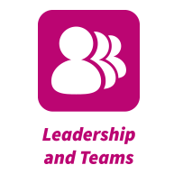 | Leadership and Teams Leading improvement in your system is a core feature of leadership. At the outset the leader will create conditions and outline the need for change, and bring together a team to address the problem, setting goals and sharing the vision.  Leaders can create a culture within the team that optimises project performance, cultivating the factors which characterise effective teams.  Leaders should also develop better understanding of themselves through self-analysis and reflection: personality, leadership style, approach to conflict. This will help them both lead the project and grow as a future senior leader in EM.  It should also be noted that leadership in QI is not confined to senior staff. Leadership attributes can be developed at any stage, and more junior team members can contribute to the leadership of the project even if not ostensibly the project principal. | - Myers-Briggs test  - Six Leadership Capabilities  - Lencioni’s Five Characteristics of a High-Performing Team  - Kotter’s 8 Steps  - Steven Covey’s 7 Habits  - Self-reflection on leadership personality / style

