Appendix 4
RCEM Curriculum
Further guidance on Generic SLO

Supporting material detailing Specialty Learning Outcomes SLO9-SLO12

A practical guide for Trainees,
Supervisors and ARCP panel

Appendix 5 QIAT Forms x4
RCEM QIAT(2024)

EM Quality Improvement Assessment Tool
Trainee Name | Click here to enter text.
Trainee GMC | Click here to enter text.
Trainee Post | ACCS ST1/2
Date of Completion | Click here to enter a date.

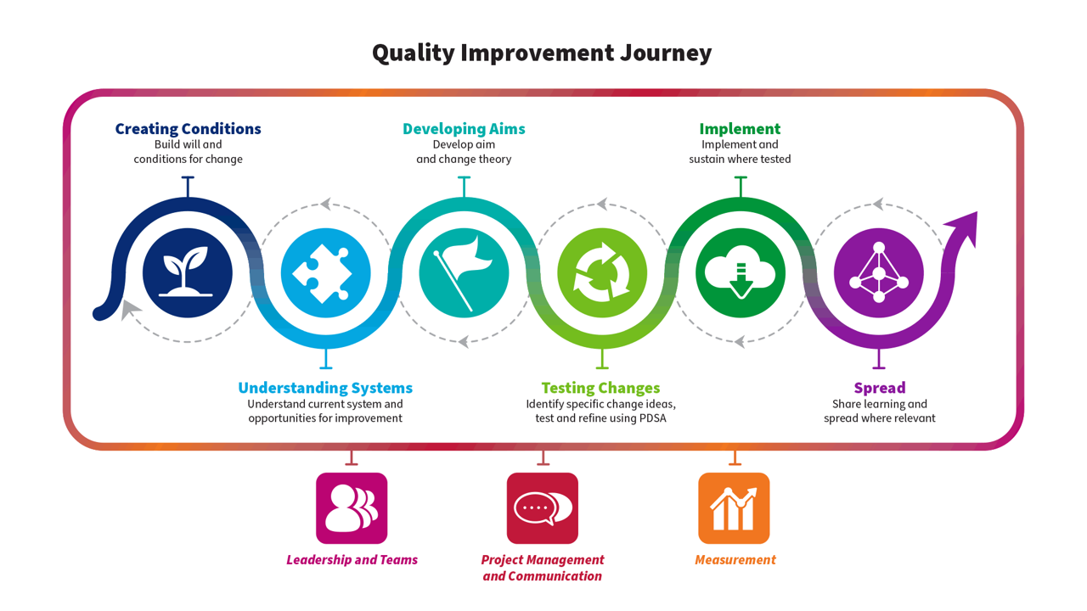
Part A – For trainee to complete – Please use this tool to describe the Quality Improvement activity you have undertaken this year. Where a section is not applicable please add N/A. Please copy and paste your Personal Development Plan from the previous year below if applicable.

1 - QI Personal Development Plan - previous year
1.1 PDP

Please share your QI PDP from the previous year if applicable: what was your objective for the next stage in your QI development?
ACCS ST1 – N/A
ACCS ST2 - QI PDP from ST1:
- To gain further understanding of the QI Journey and the aspects that are involved by reviewing the Quality Improvement Zone on TURAS Learn
- Complete e-learning modules to start to understand different QI Methodology and what QI Tools are available.

2 - QI Education
2.1 Involvement

Please describe your engagement with QI Education over the past year. This can include online learning or attendance at local/national courses.
Over the past year I have undertaken e-learning modules on Quality Improvement which I have linked to my portfolio alongside completing e-learning, I attended the RCEM QI study day and monthly departmental QI meetings.

2.2 – Learning

How did this develop your knowledge of QI? How do you feel this will help your future QI work? Please map to the QI journey above if applicable. Separate reflections uploaded on Kaizen can be linked to this section.
The e-learning I have completed over the year has improved my understanding off the following QI tools – PDSA cycles, Driver Diagrams, Process Mapping, Stakeholder analysis and when these tools can be used to help analyse the problem along with where they fit into the Quality improvement journey. Along with the QI tools I have also gained further understanding of when Run charts and SPC charts can be used as measurement tools.

The RCEM QI Study day was an insightful day into what QI is and isn’t along with tips on how to develop my own QI and useful breakout sessions with examples on how to analyse the problem, engage stakeholders, generate change and measure success. What I learnt on this day I hope to take foreword through training for when I lead on a project and take on more of a leadership role.

The departmental QI meetings were a chance for me to see what projects were ongoing within the department and gain insight to what went well with some projects and what didn’t go so well and the challenges that team have faced. This will benefit me in the future as depending on what project I take lead on from shared experience of colleagues I may be able to plan / prepare for similar challenges that may occur within the early stages of planning QI and highlights the importance of creating conditions withing the QI journey.

3 - Project Involvement
3.1 – Overview

Please provide an overview of any project you have been involved with this training year. This should reflect the project and not your personal involvement in the project. Please give as much detail as you can including aims, measurement plan etc if possible.
Background: This QI came about as we know pressures on Emergency Departments (ED’s) require novel ways to streamline care and improve efficiency. Isolated head injury in paediatric patients is a common presentation to the ED, often with minimal if no clinical intervention needed. This was shown in research carried out in the Head Home: a prospective cohort study of a nurse-led paediatric head injury clinical decision tool at a district general (Aldridge P, et al. Emerg Med J 2020;37:680–685). They were able to show that the Head Injury Discharge at Triage Questionnaire (HIDATq) had a negative predictive value (NPV) for CT of 99.9% and a NPV of 100% for intracranial injury and that it appeared safe to use in their district general hospital and that potentially 20% of head injuries presenting to ED could be discharged at triage with this increasing to 50% if included lacerations and abrasions.

At the DGH, initial data collected from 20/3/2023 to 17/09/2023 showed that on average 41.4 paediatric patients a week were attending with an isolated head injury and spending on average 145 minutes in the department.

Aim: To safely reduce the total time spent in the department by 50% for isolated paediatric head injury by a nurse lead triage screening questionnaire in the form of a proforma by September 2024.

Measures:
Outcome measure: The total time a paediatric isolated head injury patient spent in the ED
Process measure: The percentage use of the proforma
Balance measure: The total time to triage – we wanted to check by adding an additional step for the triage nurses we weren’t significantly increasing triage time.

Results:
Over the period 22/4/2024 to 02/09/2024 our outcome measure of total time in the department decreased from an average time of 145min in the department to an average of 91 minutes including those paediatric patients requiring a clinician review. Excluding those patients that required a review by a clinician and were able to be discharged from triage the average time in the department reduced to 42.9minutes.
Our process measure – from implementation of the proforma usage went from 18% to 75% at the end of the period.
Our balance measure of time to triage showed no increase in time to triage with the implementation of the proforma.

Interventions
From 22/04/2024 to 02/09/2024 we carried out 8 interventions via PDSA’s
- Implementation – Education, Proforma, Governance
- Proforma through ED governance 13/04/2024 – needed adaptation to version 2 without release.
- Ran education session for nurses
  - Showed proforma was safe. - Referencing HIDATq
  - Return rate, proof to nurses if use proforma they have backup from ED Governance
  - Trust supported
  - Certificate for completion of training
- Proforma Version 2 added safeguarding concerns & over 1 year triage experience to be able to use proforma

- Handover reminder
- Proforma Version 3 – Added in question - is the wait at triage safe to use proforma?
- Proforma Version 4 – added in doctor, ENP, ANP and name of clinician reviewing wound
- Handover reminder of wound review process – not to be put back in time order
- Targeted discussion with nursing staff & Identified Champion (Now lead nurse for HI discharge at Triage)
- Paediatric Nurse development days feedback and update on progress, Version 5 proforma, identifying appropriate nurses with less than 1 year experience who would be suitable for training.
- Targeting new trainees in August for reminder of HI Proforma.

Document linked to QIAT which shows recent version of proforma, stakeholder analysis, driver diagram and run chart of results.

3.2 – Personal Involvement

Please describe your personal involvement with the project and relate to the QI journey above. What was your role in the project? Please include any QI tools used. These can be uploaded separately and linked.
My main role for the project was data collection this involved liaising with business intelligence team to create a search which would allow us to identify isolated head injuries and timings we required from the electronic patient record. I then compiled a spread sheet on excel to input anonymised data into along with colour coding system, from this the ST3 was then able to analyse the data and plot onto a run chart. (Run chart linked to QIAT form)

I was involved in delivering the education session to triage nurses on how to use the proforma prior to its implementation which was part of the first intervention in our 8 PDSA cycles, once the proforma had been introduced I was then involved in gathering feedback from the key stakeholders after each intervention – along with the weekly data this allowed us to make further improvements to the proforma along with clarifying certain processes around managing a head injury with a laceration/abrasion.
3.3 – Team working & Stakeholders
Please describe the team involved. How did the team work together, and what was your role in the team? How was your contribution encouraged? If you led the project team, what was your rationale for recruiting the other team members, and what project roles did you allocate them? Were there any difficulties in how the team functioned, and if so, how were these addressed? How did you engage with stakeholders outside the project team? Did you engage with patients and other users?
The QI team was made up of an ST6 who was the QI lead, an ST4, myself, senior Paediatric Sister, Link nurse and PEM Consultant. Team members came onboard at different stages of the project but all contributed towards the aim.

The team worked well throughout the duration of the project we all had a shared goal that we wanted this to QI to succeed as we all felt would benefit patients not spending long time in the department but also for the staff reduce the number patients and parents/carers in the waiting room and less people asking how long the wait was. The ST6 organised regular meetings to discuss up to date results and feedback which allowed us to keep the momentum going as well as creating a supportive environment.

Stakeholders outside the project team were engaged by presentation at ED Governance along with the triage staff having education sessions about the project and the proforma prior to implementation, we also asked them for regular feedback on the proforma and it’s implementation which allowed us to answer any concerns raised.

We didn’t formally ask for feedback/engage patients but after implementation a friends and family test response stated how impressed they were with how quickly they were triaged and discharged following the use of the proforma.

3.4 Reflections

What do you think went well? What didn’t go so well? What will you do differently next time?
I think what went well with this QI was the engagement of key stakeholders early and involvement of them in each intervention, this I feel helped lead to the success of the project. Following the education session’s, the nursing staff were all enthusiastic about the project.
The team worked well and identified problems early and made changes when they were identified, the data was analysed quickly after each cycle which allowed us to move quickly onto the next PDSA cycle without too much of a delay between each intervention.
Data collection at first was slow for the first few weeks but once I knew how to find the information required from electronic patient records this process was less time heavy and was easy to collect weekly data.

Looking back the one thing we would have done differently was being clearer in the education sessions about how we wanted head injuries with lacerations/abrasions managed as shortly after implementation of the first proforma it became clear what we had wanted to happen which was them to just be reviewed and managed in triage / shortly after wasn’t happening and were then being put back to await full clinician review when they’d screened negative on the screening questionnaire.

3.5 – Sharing of results
Did you have the opportunity to share your work with a wider audience? Please share details linking in any posters or presentations.
I presented the QI project at local trust QI showcase and we had a poster at the RCEM annual scientific conference.

4 - Learning & Development
4.1 The QI Journey

In which aspect(s) of the QI Journey did you feel you gained experience this year (tick all that apply)?
- Creating Conditions x
- Understanding Systems x
- Developing Aims
- Testing Changes x
- Implement
- Spread x
- Leadership & Teams
- Project Management & Communication
- Measurement x
4.1 Learning

Longitudinal learning in Quality Improvement - Please outline what this year has contributed to your development and knowledge of QI. How has this compared to your personal development plan from the previous year?
This QI has helped broaden my understanding of the different stages involved in the QI journey building on the e-learning I had previously completed.
This project has shown the importance of stakeholder engagement in the early planning stages of the project and to get them onboard prior to implementation of changes. As a rotational trainee moving to different departments engaging stakeholders is an important part of understanding systems as what might work well in another department may not work as well in another.
I have been involved in testing changes via PDSA cycles and have a better understanding of what is involved in each stage of the Plan, Do, Study Act tool.
The measurement of QI covers several stages of the journey my involvement in data collection for this QI has taught me how to select what to measure and how to capture the data, store the data securely along with how to analyse and present the data in the form of a run chart.

4.2 QI Personal Development Plan

Please describe your plans for next year in QI. What do you hope to learn/achieve? How do you hope to contribute to improving patient care?
Moving forward with my QI journey next year:
- I would like to step up and take on more of a leadership role within a team by managing a small group involved in data collection.
- To gain further understanding of the developing aim stage of the QI journey from developing SMART Aim, change theory and the QI tools that are available to aid this.
- To be involved in a national RCEM QIP at a departmental level.
4.3 End of training - QI development journey

Please provide a summary of your development journey in QI and leadership throughout your EM training, with references to specific examples. How will you apply your development in QI as an EM consultant?
N/A

Part B – For trainer to complete – Please use this tool to assess the Quality Improvement activity your trainee has undertaken this year. Please refer to the QI journey resource to understand the types of tools & methodologies your trainee may describe/share to evidence their learning at each point of the journey.

Note that the Academy of Medical Royal Colleges in ARCP guidance states that “trainees do not need to design, lead, and project manage entire QI projects to satisfy curriculum requirements”

1 – Feedback – What has been done particularly well?

Thanks for sharing your involvement in QIP this year. It looks like you and your team were busy with the number of PDSA cycles and it shows your results that by adapting and implementing different actions has resulted in positive change to your department.

You have clearly demonstrated that to bring about change you have to create the conditions to do so by engaging stakeholders and understanding systems.

From your QIAT it shows that you worked well with your QI team and each of you had your role to play which is important in QI as it can be difficult to implement change when trying to do QI solo.

2 – Learning points – What could have been done differently?

Reading through your QIAT there’s very little I think you could have done differently – you worked well as a team player, engaged stakeholders, collected data which allowed your team to act on and implement multiple PDSA cycles. You have undertaken eLearning and attended QI study days – was there any learning from these you shared with the team?

You also mentioned you would have done one thing differently when it came to the education sessions you delivered how could you have made things clearer?
2 – Recommendation for further learning or development

As you have already reflected on look to take the next step in QI by leading a on a QI / leading in an area of the QI journey within your team.
Take a look at EMLeaders eLearning modules.
Have a look at the National RCEM QIPs that are going to be happening the coming year.
4 – Overall
Please indicate the level of the trainee’s performance in this QIAT
Please select
- Below expectations
- Satisfactory/ Good
- Excellent

Signoff and actions
Please ensure this form is signed off by both the Assessor and Trainee via the "Link" button next to the form once saved.
Assessor Name | Assessor Designation / Job Title | Date
 |  | Click here to enter a date.
Assessor GMC Number | Assessor email address

