RCEM QIAT(2024)

EM Quality Improvement Assessment Tool

Trainee Name | Click here to enter text.
Trainee GMC | Click here to enter text.
Trainee Post | ST3
Date of Completion | Click here to enter a date.

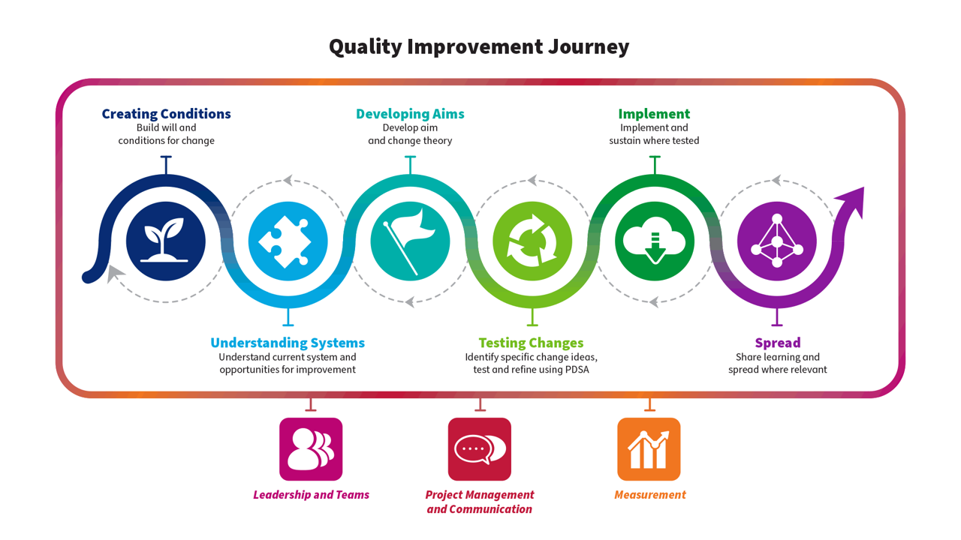
Part A – For trainee to complete – Please use this tool to describe the Quality Improvement activity you have undertaken this year. Where a section is not applicable please add N/A. Please copy and paste your Personal Development Plan from the previous year below if applicable.

1 - QI Personal Development Plan - previous year
1.1 PDP

Please share your QI PDP from the previous year if applicable: what was your objective for the next stage in your QI development?
ST2:
- to have a more active role in the intervention side of a QIP
- to go to the pan-London QI training day

2 - QI Education
2.1 Involvement

Please describe your engagement with QI Education over the past year. This can include online learning or attendance at local/national courses.
I wasn’t given a QIP to work on in ST2, so I did a lot of e-learning modules last year

- ST3 Induction day: talk by the London QIP lead
- Attended the pan-London QIP training day in September. I found this to be quite a useful day, as it gave me the chance to try out QI tools on a hypothetical QIP. There were several small-group exercises with residents of other grades which was a good experience. Learning points: QI skills and leadership skills are interchangeable; you can do QIPs on any topic eg., green; driver diagrams are important tools for planning a project at the outset

2.2 – Learning

How did this develop your knowledge of QI? How do you feel this will help your future QI work? Please map to the QI journey above if applicable. Separate reflections uploaded on Kaizen can be linked to this section.
- ST3 Induction day talk: helped me understand what changes are coming in the QIAT. This was quite reassuring, as I was a little nervous about the expectations for QIP as progressed in training

- Pan-London QIP training day: I found this to be quite a useful day, as it gave me the chance to try out QI tools on a hypothetical QIP. There were several small-group exercises with residents of other grades which was a good experience.
Learning points:

  - QI skills and leadership skills are interchangeable;
  - you can do QIPs on any topic eg., green / wellbeing
  - driver diagrams are important tools for planning a project at the outset

3 - Project Involvement
3.1 – Overview

Please provide an overview of any project you have been involved with this training year. This should reflect the project and not your personal involvement in the project. Please give as much detail as you can including aims, measurement plan etc if possible.
PROJECT: Reducing computer screen brightness

BACKGROUND:
I was assigned to this project as part of the department’s application for Bronze accreditation in the RCEM Green ED programme. This was domain 5: ﻿Computer electricity use minimised. The ED can evidence a reduction in computer energy use. Recently the Trust had installed an automatic shutdown app for all computers after 30 minutes, in order to save energy from PCs being left on overnight. However, in computers in 24/7/365 areas (one of which was the clinical areas in ED), they are in use so often that the 30-minute shutdown doesn’t trigger.

As an alternative our Sustainability lead in ED looked at ways of reducing energy use without shutting down the PCs, and hit upon the idea of reducing screen brightness. It was proposed that a moderate reduction in screen brightness would not be noticed, or at least would be tolerated, by staff and would not compromise patient safety by making it more difficult to read x-rays. When I rotated to the ED, my educational supervisor suggested this as a ‘quick win’ that could be completed in 6 months.

AIM:
To implement a safe reduction in computer energy use in ED clinical areas, by a reduction in screen brightness from 100% to 40%, over 6 months

ANALYSIS OF THE PROBLEM:
Initial conversation with ICT:
- All PCs in the ED are one of 3 models of Dell computer
- 140 PCs in clinical areas (which don’t have the power-down installed)
- On average, a clinical PC is on for 17.5h a day, 7 days a week
Baseline power measurement:
- Sample of 13 PCs from selected areas across the ED
- Power meter attached to PC AC plug and then plugged into mains socket
- 24 hours of use by regular staff members
- Power consumption: 52.8W
- 0.77 kWh energy use (Kappa 0.79)
We also did a driver diagram to generate change ideas and come up with ideas for the blind testing.

MEASURES:
Outcome:
- Reduction in CO2e after turning down screen brightness in all PCs in ED clinical areas
Process:
- Power measurement in selected sample of PCs, using common apps such as Cerner EPR, Google Chrome and PACS
- Kappa scores of power measurements between two people
Balancing:
- Noticeable difference in screen brightness in a blinded test of ED staff
- Perceived difference in x-ray clarity on PACS in a blinded test of staff

INTERVENTIONS:
- Getting baseline power measures for a selection of PCs at 100% screen brightness
- Performing blinded tests of staff to determine whether a lower screen brightness was noticeable
- Blinded tests of staff to determine whether they perceived greater difficulty in reading x-rays on the PACS system
- Reducing screen brightness to 40% in all 140 PCs in the ED
- Power measurements for the same selection of PCs at 40% screen brightness
- Calculation of CO2 emissions savings

RESULTS:
Power consumption at 40%: 35.2 (using same method as above)
0.46 kWh Energy use (Kappa 0.82)
Consumption difference per monitor per hour = 4.7Wh = 0.0047kWh
Extrapolated to 140 monitors per year = 4202.975 kWh
Total kg CO2e / kWh = 0.19338 (from Health care's response to climate change: a carbon footprint assessment of the NHS in England. Lancet Planet Health. 2021 Feb;5(2):e84-e92. doi: 10.1016/S2542-5196(20)30271-0.)
Estimated annual carbon savings = 812.77 kg CO2e

NEXT STEPS:
- Revise brightness setting to 50% to comply with RCR standards (see section 3.5), and recalculate emissions savings
- Roll out screen brightness reduction across the whole Trust, in all clinical and non-clinical areas

3.2 – Personal Involvement

Please describe your personal involvement with the project and relate to the QI journey above. What was your role in the project? Please include any QI tools used. These can be uploaded separately and linked.
My role in the project was to be responsible for the interventions in the ‘mini-QIP’. The overall project lead, Dr G, asked me to manage the plan, which she had devised, and support HK and AM in their tasks, keeping to the timeline. I used a Gantt chart to help with this. As the project manager for this QIP, I reported back to Dr. G on a monthly basis, to update her. I got feedback and advice whenever I hit any bumps in the road.

3.3 – Team working & Stakeholders
Please describe the team involved. How did the team work together, and what was your role in the team? How was your contribution encouraged? If you led the project team, what was your rationale for recruiting the other team members, and what project roles did you allocate them? Were there any difficulties in how the team functioned, and if so, how were these addressed? How did you engage with stakeholders outside the project team? Did you engage with patients and other users?
The team consisted of myself, a CT1 and a Band 5 nurse.
The primary lead of the Green ED was Dr. G, the department sustainability lead, and it was she who delegated the screen brightness project to me. Dr M, the department QI lead, then allocated HK, an ACCS CT1, to the team and managed to recruit AM, a Band 5 nurse too.

HK and AM took on the tasks of getting before and after power measurements. We bought a power meter online – essentially a plug adapter which plugs into the PC plug and then into the mains socket. We then independently tested the power for 2 hours on a random sample of 6 PCs, using common apps such as Cerner EPR, Google Chrome and PACS. They then ran a Kappa score on their respective measurements, which showed good correlation.

I ensured that they were undertaking their tasks correctly, and made sure they had time set aside to gather the data (in HK’s case, she had 3 hours of EDT a week). I put together a Gantt chart to plot the interventions and stages of the project, against a timeline. We generally kept to the timeline. HK was very keen and used her EDT effectively. AM was keen but struggled to find time outside of clinical shifts. Dr. G escalated this to the matron who kindly sometimes ensured that AM had cover with a float nurse when he went to take power measurements. However it was challenging to get that much engagement from AM.

Dr. G did a stakeholder analysis, and decided that the main stakeholders were the registrars, consultants and ICT. This was helpful at the outset and we got buy-in from all staff groups. However we didn’t predict the intervention of the physicists from radiology (see below)

3.4 Reflections

What do you think went well? What didn’t go so well? What will you do differently next time?
- Went well: getting engagement from ICT. Use of data to show the need for improvement and then to show that we brought about an improvement. I thought I did fairly well to get the project done in 6 months, although it will need another cycle after the recalculation (see below). Our own balancing measure exercises went well
- Didn’t go well: difficult to get much action from nurse AM
- Learning for next time: learning how to motivate colleagues – what’s in it for me? Also engaging with senior nursing colleagues to give time and permission for nurses to do QI work, and having that in place at the start of the project. More in-depth stakeholder analysis, maybe as a team brainstorming session, to come up with stakeholders that may potentially have an objection to our project, and then pre-empting that by meeting with them early.
3.5 – Sharing of results
Did you have the opportunity to share your work with a wider audience? Please share details linking in any posters or presentations.
The project was presented at the ED QI half-day, and then a write-up posted on the intranet, as an example of a successful Green QIP. I also presented the project to a delegation of Danish clinicians who were visiting the hospital to learn about our various Green initiatives.

This was received very well by the delegation, but at the meeting were staff from various different departments, including a physicist from Radiology. She pointed out that there are RCR standards for non-Radiologist reporting computer screens, in terms of resolution of graphics and luminance, and that the 40% setting may not meet those standards for patient safety.

My consultant lead Dr. G agreed to have the physicists visit the ED and conduct luminance tests on a sample of PCs. This will take place in the near future, and if 40% comes out as having insufficient luminance then they will conduct further tests to give us the lowest brightness setting that meets the RCR standard, so that we may then readjust our PCs. We hadn’t thought about RCR standards when we were doing the stakeholder analysis and planning balancing measures.

4 - Learning & Development
4.1 The QI Journey

In which aspect(s) of the QI Journey did you feel you gained experience this year (tick all that apply)?
Creating Conditions
Understanding Systems
Developing Aims
Testing Changes x
Implement x
Spread x
Leadership & Teams
Project Management & Communication x
Measurement x
4.1 Learning

Longitudinal learning in Quality Improvement - Please outline what this year has contributed to your development and knowledge of QI. How has this compared to your personal development plan from the previous year?
This was an enjoyable year, as it was the first opportunity to get involved in implementing changes in a project. I was also entrusted with a deputy leadership role, in a mini-project which was part of a wider project in the ED. I learnt about leadership, motivating others and keeping to a project timeline. It was also the opportunity to use data and make calculations to produce the main outcome measures.

In terms of metrics, I learnt about the concept of process measures and balancing measures. The driver diagram exercise helped us come up with the balancing measures – ensuring that reducing screen brightness would not compromise patient safety.

It was also enjoyable and satisfying to be working on a Green project. I have long had an interest in environmental sustainability in my personal life, and I feel strongly that we are in a climate emergency, so working on a project focused on improving sustainability in our ED was incredibly rewarding to me. It was also reassuring to know that we’re not required to confine ourselves to clinical QIPs only.

I’m satisfied that this year’s experience allowed me to achieve the PDP objective of taking a more active role in a QIP. In ST2 I had no experience of working on a project in either of my rotations.

4.2 QI Personal Development Plan

Please describe your plans for next year in QI. What do you hope to learn/achieve? How do you hope to contribute to improving patient care?
- Act as the project lead setting up a new QIP. Focus on building a team, engaging with stakeholders
- Involve patients and users in the QIP eg., feedback, focus group, co-design
- Do a QI leadership course / modules. This could be at my next Trust or an external provider eg., NHS Elect
4.3 End of training - QI development journey

Please provide a summary of your development journey in QI and leadership throughout your EM training, with references to specific examples. How will you apply your development in QI as an EM consultant?
N/A

Part B – For trainer to complete – Please use this tool to assess the Quality Improvement activity your trainee has undertaken this year. Please refer to the QI journey resource to understand the types of tools & methodologies your trainee may describe/share to evidence their learning at each point of the journey.

Note that the Academy of Medical Royal Colleges in ARCP guidance states that “trainees do not need to design, lead, and project manage entire QI projects to satisfy curriculum requirements”

1 – Feedback – What has been done particularly well?

Hit the ground running: got started on the baseline measures through good engagement with ICT
Very pleased that he then led his small team to put in place the changes and repeat power measures. Followed by CO2e calculations in a reasonable timeframe. He was engaged with the process and checked in with me regularly, which meant that I was kept updated but could also give him guidance as we went along. Keen learner who made useful contributions to the design of the project. Showed knowledge of QI tools. Should also take into account that he only had 6 months on the project, so the progress made is excellent. The issue with the physicists and RCR guidelines was unexpected, and out of his control.

2 – Learning points – What could have been done differently?

Could have got more out of the band 5 nurse in his team. I think he tended to put off engaging with them when there was radio silence. Could have escalated to the matron earlier to get support for the band 5 in doing the project

2 – Recommendation for further learning or development

He is ready to take the lead on a QI project as he enters higher training. He has a sound grasp of QI methodology and the process to follow. To support with this, I would recommend he does some e-learning or a course on leadership in general – this will also stand him in good stead as a senior EM resident.

4 – Overall
Please indicate the level of the trainee’s performance in this QIAT
Please select
- Below expectations
- Satisfactory/ Good
- Excellent

Signoff and actions
Please ensure this form is signed off by both the Assessor and Trainee via the "Link" button next to the form once saved.
Assessor Name | Assessor Designation / Job Title | Date
 |  | Click here to enter a date.
Assessor GMC Number | Assessor email address

