Appendix 5 QIAT Forms x4
RCEM QIAT(2024)

EM Quality Improvement Assessment Tool
Trainee Name | Belle Curve
Trainee GMC | 543210
Trainee Post | ST4
Date of Completion | 1st February 2025

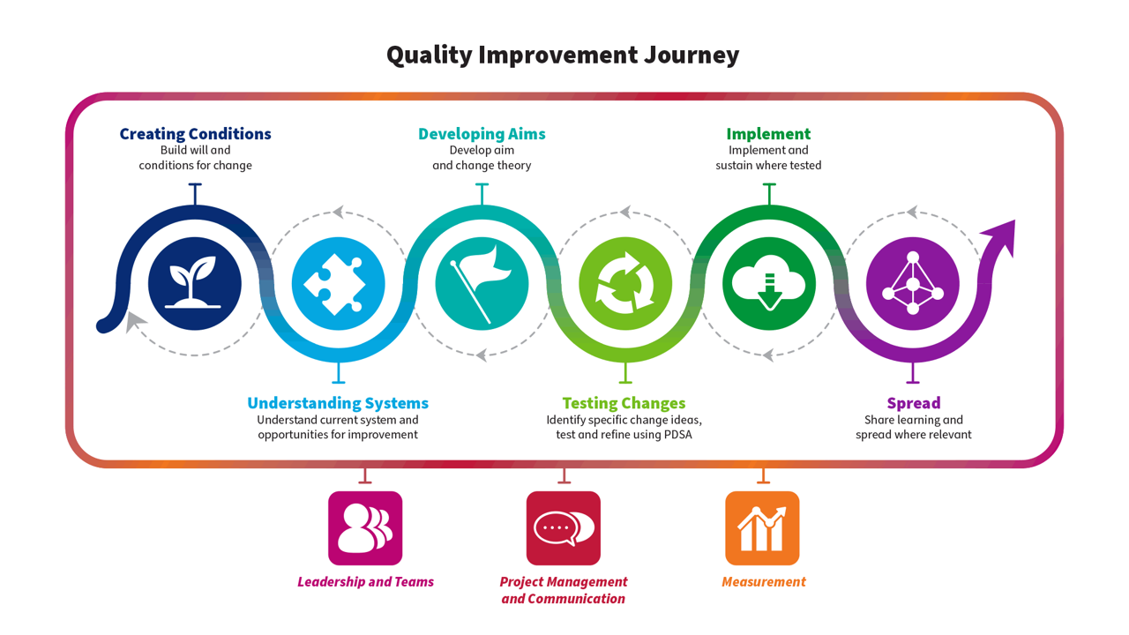

Part A – For trainee to complete – Please use this tool to describe the Quality Improvement activity you have undertaken this year. Where a section is not applicable please add N/A. Please copy and paste your Personal Development Plan from the previous year below if applicable.

1 - QI Personal Development Plan - previous year
1.1 PDP

Please share your QI PDP from the previous year if applicable: what was your objective for the next stage in your QI development?
The main objective set at my last PDP was to assume more of a leadership role and focus on project management and communication.

2 - QI Education
2.1 Involvement

Please describe your engagement with QI Education over the past year. This can include online learning or attendance at local/national courses.
Locally
I attended departmental QI teaching. This was a project workshop where each project was shared with others. By sharing my project, fielding questions from the audience and listening to others, I got some great ideas about how to develop the project. I also attended the trust/board’s QI celebration event where I got to hear about other QI projects outside the ED.

Nationally
RCEM ran a workshop related to the National QIP that I’m co-leading on in the department. It shared some of the most frequently asked questions as well as best practice by describing how other centres overcame certain issues.

2.2 – Learning

How did this develop your knowledge of QI? How do you feel this will help your future QI work? Please map to the QI journey above if applicable. Separate reflections uploaded on Kaizen can be linked to this section.
I feel that my learning links to understanding systems, leadership and teams and project management & communication.

It was really good to hear what others were doing in the department. I picked up some great tips on who I could contact in medical illustration to help develop some of the materials I need for the QIP. Clinical work is really challenging at the moment and it was good to know that I wasn’t alone, others in the department are feeling the same. In fact, it would appear the feeling is national! Some of the others mentioned EMLeaders programme. I’ve heard of it before but just haven’t had a chance to look into it yet. They really rated it and felt it helped them to better understand themselves in a leadership capacity and how they can better work with others. Definitely on my to do list now.

A few of the departmental consultants were at the meeting and they had the opportunity to hear how the projects were going. They’ve been there so long that they gave really valuable insight into some of the processes that I just wasn’t aware of. It was also good to get the opportunity to share how we were collectively feeling. Not only did I pick up some QI tips but it felt like we also had an informal peer support session.

Hearing what was going on elsewhere in the board was really interesting. It’s very easy to think of ED only but there are lots of problems across the healthcare setting that people are looking to improve. I was buoyed by meeting others who want to improve things, ED isn’t alone. I got the opportunity to meet the QI team in the board and they shared how they could help us with our project. I didn’t know they existed! I’ve now been added to the Team so it’ll be easier to access the help I need when I need it.

I really enjoyed the national RCEM workshop. We are really struggling with making improvements in achieving our standard. I reflected on this workshop separately and have linked it to this section.

For me the big learning that I’ll take with me is that I’m not alone. I’ve really benefited from making these new connections. It’s signposted new learning resources, given me some tips and really forced some much needed reflection on my part. I’m so busy trying to ‘do’, that I just hadn’t scheduled reflective to learn from everything I’m doing.

3 - Project Involvement
3.1 – Overview

Please provide an overview of any project you have been involved with this training year. This should reflect the project and not your personal involvement in the project. Please give as much detail as you can including aims, measurement plan etc if possible.
This year I have become involved with the RCEM Care of Older People QIP. It’s currently in Year 2.
- The overall aim of the national QIP is to improve the quality of care for patients 75+ and older in EDs by:
• Improving screening for delirium, screening for frailty, and falls risk assessments,
• Ensuring actions are taken based on the findings of those screenings and assessments,
• Ensuring patients have their basic care needs met whilst in the emergency department
- We focused on delirium screening as this is something we’re finding challenging.
- Aim: To improve the screening for delirium in the ED from 10% of patients to 20% by August 2026
- Measures:
  - Outcome - Was delirium screened for?
  - Process - Which screening tool was used? Time/Day of Presentation. Which member of the team undertook the screening?
  - Balance - Time in the department
- Results: So far there has been no improvement in the % of patients undergoing delirium screening in our ED.
- Interventions: Year 1 consisted of gathering data to understand the system. They undertook process mapping and surveys. It is only now that we have agreed that we are going to focus on the screening element and are planning our interventions.
3.2 – Personal Involvement

Please describe your personal involvement with the project and relate to the QI journey above. What was your role in the project? Please include any QI tools used. These can be uploaded separately and linked.
This QIP has already been running for a year and I took over from a colleague. My role in this project is leading, managing and communication whilst we test changes with a view to implementing those that show improvements. I have linked in the process mapping previously undertook. I have attached the stakeholder analysis and driver diagram that I developed with the team.

3.3 – Team working & Stakeholders
Please describe the team involved. How did the team work together, and what was your role in the team? How was your contribution encouraged? If you led the project team, what was your rationale for recruiting the other team members, and what project roles did you allocate them? Were there any difficulties in how the team functioned, and if so, how were these addressed? How did you engage with stakeholders outside the project team? Did you engage with patients and other users?
My main focus so far has been from a leadership pov. This was an obvious next step for me given my PDP from previous QI work. I met early with my educational supervisor and was clear on what I needed to achieve. They were very encouraging and suggested this might be a good QIP to join in with. Regionally our TPD and QI lead are good at ensuring as a group of trainees we share the QI work that we’ve done/are doing and opportunities to handover when we know our allocations.

I met with my colleague who led on Year 1 and it was obvious they were now at the stage to proceed with the aim they’d focused on out of the various aims shared in the national QIP. As I’m LTFT I moved slightly out of sync from the August rotation. Whilst this isn’t always ideal it did give me the opportunity to do a transition with the previous QIP lead and some of the original resident doctors were still there.

When I joined the team it was purely composed of EM medics. I decided a stakeholder analysis was vital to ensure we didn’t miss key stakeholders who not only knew aspects of the system that we didn’t but had ability to influence areas that we didn’t. I’ve linked this.

We quickly identified that we needed to expand to include EM nursing representation and ideally get an EM consultant on board too. We have a very proactive clinical service manager who’s just joined us from the frailty service so we reached out to them too. We are very lucky to have frailty practitioners every morning so they were also included in the team.

The above conversations were easy to have and were well received. Our management rep is able to help facilitate conversations with other managers and our frailty practitioners were able to introduce/involve key members of their team outside the ED. A great addition to the team as a result was one of the managers who works in the community.

So far we’ve not had any problems from within the team. Everyone has been respectful and reasonable. The only real issue is that at times, given how passionate team members are I have to help set realistic expectations. I think this is successfully demonstrated in the realistic aim we’ve set ourselves. We are looking for gradual improvement over time.

Currently we have not engaged with patients or public directly but use tools like CareOpinion and surveys that the board intermittently share with patients on their experience.

3.4 Reflections

What do you think went well? What didn’t go so well? What will you do differently next time?
I am absolutely delighted at the team we’ve brought together. It’s a real step forward and brings us closer to realising our aim.

My main frustration has been time. There are just not enough hours in the day and it’s incredibly difficult to find times to get everyone together. I recognise this across the system, not just within this QI project. Initially I was really disappointed if I didn’t get everyone around the table at the same time but now I realise that this would have been the exception, not the norm. Like our aim, I have to be realistic.

Given this new appreciation I would ensure we had a broader communication system not reliant on meetings from the outset. I’ve now adapted for this particular project and we have an active teams site. I’ve also become more familiar with online collaborative tools like Miro board.

3.5 – Sharing of results
Did you have the opportunity to share your work with a wider audience? Please share details linking in any posters or presentations.
As detailed above, I’ve linked the presentations I shared.

4 - Learning & Development
4.1 The QI Journey

In which aspect(s) of the QI Journey did you feel you gained experience this year (tick all that apply)?
- x Creating Conditions
- x Understanding Systems
- x Developing Aims
- x Leadership & Teams
- x Project Management & Communication
4.1 Learning

Longitudinal learning in Quality Improvement - Please outline what this year has contributed to your development and knowledge of QI. How has this compared to your personal development plan from the previous year?
I really feel that I’ve grown as a leader. I realise the importance of having a team and involving stakeholders out with the ED. I have a greater understanding of how to improve comms as without them it leads to people not knowing what they need to know and things just not happening. This very much fits with my previous PDP but I have learnt so much more too. It’s really important to identify networks whether within or outwith the department to tap into the support that’s needed. Whilst my Educational Supervisor has been great, there are some things they just don’t get in relation to QI. Having peer support and others on their own QI journey has been really valuable and helped me keep it realistic.

4.2 QI Personal Development Plan

Please describe your plans for next year in QI. What do you hope to learn/achieve? How do you hope to contribute to improving patient care?
I still have time left in this department because of being out of sync. My team will be changing as the others rotate. This will be challenging and a test of my leadership skills. When we’re assembled I’ll have a chance to get stuck into some of the change ideas using my PDSA cycles.

I plan on completing the online EMLeaders programme and I’d really like to learn more about how to spread improvements. I don’t anticipate I’ll be able to do this during this placement, reckon this will be something to look forward to at the end of training when I have a substantive consultant post but I am curious and would like to learn more. I’ve heard of the Q community run by the Health Foundation. It’s online and there are lots of SIGs that I plan to explore.

The next board/trust QI event lands just before I rotate. I will aim to share via poster or presentation there.

4.3 End of training - QI development journey

Please provide a summary of your development journey in QI and leadership throughout your EM training, with references to specific examples. How will you apply your development in QI as an EM consultant?
N/A yet

Part B – For trainer to complete – Please use this tool to assess the Quality Improvement activity your trainee has undertaken this year. Please refer to the QI journey resource to understand the types of tools & methodologies your trainee may describe/share to evidence their learning at each point of the journey.

Note that the Academy of Medical Royal Colleges in ARCP guidance states that “trainees do not need to design, lead, and project manage entire QI projects to satisfy curriculum requirements”

1 – Feedback – What has been done particularly well?

I really enjoyed reading your QIAT Belle, thank you for sharing. It sounds like it’s been an incredibly busy year for you and I’m really pleased that you’ve benefited from a support pov through some of the new connections you’ve made.

Often people do QI alone but it’s meant to be a team support. It’s very easy to get into a position where you feel isolated and trying to create change by yourself is almost impossible. You attended event’s that gave you the opportunity to network and make those connections, well done! People think networking is an opportunity to schmooze but it’s not, it’s the opportunity to meet new people with their new ideas and hopefully make some friends as you go. There is pretty much always something you’ll be able to bring back into your own QI work.

Well done on not falling into the trap of feeling that you have to complete a QIP from start to finish in a year! I hope we’re starting to see a change as this was previously a widely held belief. You identified what you wanted to work on and you focused your activities accordingly.

2 – Learning points – What could have been done differently?

To be honest it sounds like you’ve done a great job. You had a changeover period with the previous lead which gave you the opportunity to get up to speed. You mentioned you went to one of the RCEM QI workshops. Did you communicate your learning with the rest of the team? If so great and if not how could you do this in future. You mentioned you found it helpful.

2 – Recommendation for further learning or development

You’re doing great at identifying your own learning needs and articulated this clearly. I would support your efforts to complete the EMLeaders programme. It started well after I became a consultant so I was quite curious about the content. I’ve completed some of the modules myself and thoroughly enjoyed them.

Excited to hear how you get on with your new team, keep up the good work!

4 – Overall
Please indicate the level of the trainee’s performance in this QIAT
Please select
- Satisfactory/ Good

Signoff and actions
Please ensure this form is signed off by both the Assessor and Trainee via the "Link" button next to the form once saved.
Assessor Name | Assessor Designation / Job Title | Date
Crash Metric | Consultant EM | 28th February 2025
Assessor GMC Number | Assessor email address
9990999 | crash.t.metric@pdsacycle.nhs

