Appendix 5 QIAT Forms x4
RCEM QIAT(2024)
EM Quality Improvement Assessment Tool
Trainee Name | Click here to enter text.
Trainee GMC | Click here to enter text.
Trainee Post | ST6
Date of Completion | Click here to enter a date.

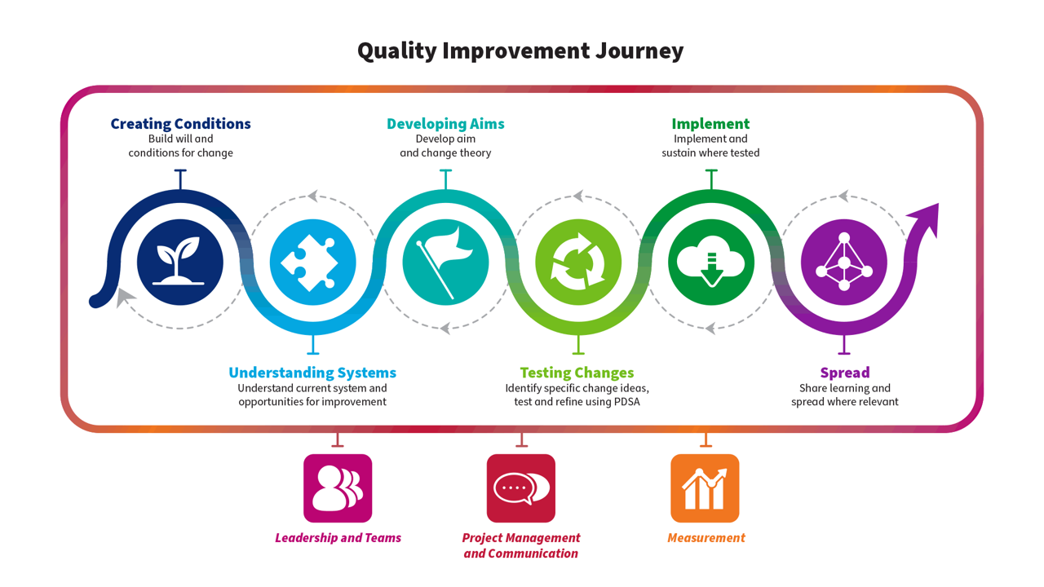
Part A – For trainee to complete – Please use this tool to describe the Quality Improvement activity you have undertaken this year. Where a section is not applicable please add N/A. Please copy and paste your Personal Development Plan from the previous year below if applicable.

1 - QI Personal Development Plan - previous year
1.1 PDP

Please share your QI PDP from the previous year if applicable: what was your objective for the next stage in your QI development?
ST5: Led QIP on improving antibiotic delivery to patient attending ED with suspected sepsis.

ST6: To mentor X with project on blood culture collection

2 - QI Education
2.1 Involvement

Please describe your engagement with QI Education over the past year. This can include online learning or attendance at local/national courses.
Completed all modules EMleaders e-learning

Completed mentoring and coaching online teaching session during RTD and GROW model of facilitated discussion

Also, learnt about 8 steps of leading change (Kotter’s 8 steps)

2.2 – Learning

How did this develop your knowledge of QI? How do you feel this will help your future QI work? Please map to the QI journey above if applicable. Separate reflections uploaded on Kaizen can be linked to this section.
Elaborate on your learning from the modules, attending QI meetings, etc. Also reflect on your learning from these modules and changes to practice.

Elaborate on learning from mentorship e-learning/sessions

3 - Project Involvement
3.1 – Overview

Please provide an overview of any project you have been involved with this training year. This should reflect the project and not your personal involvement in the project. Please give as much detail as you can including aims, measurement plan etc if possible.
Background of the project

The issue of poor-quality blood culture sampling had been noted anecdotally and reflected in contamination rates flagged by microbiology. The problem persisted due to inconsistent technique, variable staff training, and equipment issues.

Aim:
The SMART aim, co-developed with the junior colleague, was to reduce contamination rates and ensure all new clinical staff were trained and assessed in blood culture technique.
A particular learning point was guiding them to understand the importance of achievable, measurable goals — resisting the urge to "fix everything at once". It was a valuable opportunity to teach prioritisation, pacing change, and keeping focus despite the complexity of ED systems.

Measures:
Outcome and process measures were jointly selected. However, the junior initially underestimated how difficult data collection would be in practice — particularly aligning microbiology reports with ED clinical activity. The challenge of navigating silos in data ownership (and terminology differences between ED and lab teams) became a teachable moment in stakeholder communication and perseverance.
We worked through issues like inconsistent documentation, mismatched sample IDs, and the need to triangulate data. There were frustrations on their part — which I helped normalise as part of the QI learning curve — and I encouraged adaptive problem-solving rather than seeing these as dead ends. Run chart data showed modest but sustained improvements, and I guided them in interpreting this within the wider system context (e.g., staff turnover, shift pressures).

Outcome measure:
- A decrease in the proportion of false-positive blood cultures, leading to more accurate diagnoses and appropriate antibiotic use.
- Secondary outcome measure that was discussed but no specific data collected: Reduction in unnecessary treatments and hospital admissions due to contaminated samples

Process measure
- Increase in the percentage of staff following standardised protocols for blood culture collection

Balance measure:
There was a slight increase in the time taken for blood culture collection initially, as staff
adapted to following strict aseptic techniques.
Short-term delays in sample processing, as retraining staff and reinforcing best practices
required additional time.
However, long-term benefits were anticipated to include improved diagnostic accuracy,
reduced unnecessary antibiotic use, and lower hospital admission rates due to
contaminated cultures.

Results and Intervention
The junior led three structured PDSA cycles with my oversight:
- Initial technician training and sign-off, supported by the PDN.
- Expansion to include ED doctors at induction, though rollout was inconsistent at first.
- Embedding training into mandatory teaching and exploring data feedback mechanisms.
Implementation highlighted several human factors: some clinicians were reluctant to attend sessions, there was confusion around who was responsible for signing off competencies, and stock inconsistencies affected practice. The junior needed coaching in how to hold constructive conversations, escalate appropriately, and stay focused amidst competing pressures.
We regularly reflected on what went well and what could improve — using a coaching model (e.g. GROW) — to help them build reflective practice and resilience. Each cycle deepened their confidence, although I had to step in at times to manage situations that risked stalling the project.

3.2 – Personal Involvement

Please describe your personal involvement with the project and relate to the QI journey above. What was your role in the project? Please include any QI tools used. These can be uploaded separately and linked.
My role in the project was to mentor X leading this project. I had monthly meetings initially and then 3 monthly to guide their progress

First Meeting with the QIP team:
We met to discuss the project outline, process mapping and arrived at clear aims for the project. I helped X to arrive at goals that are realistic. We also looked at current team members and their role in the QIP and touched upon the possible stakeholders for the project.

Second meeting with X
Looked at progress with getting stakeholders involved.
We looked at the current data collected.
Reviewed the driver diagram and refined the measures to look at.

Third meeting with QIP team:
Looked at data to agree on aims for first PDSA cycle and refine the questionnaire

Fourth meeting with PDN and X:
Looked at current induction material for ED techs and agreed on the suggested changes

Fifth meeting:
Looked at the posters and sign off matrix developed by the team

Presentation in departmental clinical governance:
Support the team presenting

Sixth meeting:
Finalising the modules to be included in the departmental induction

3.3 – Team working & Stakeholders
Please describe the team involved. How did the team work together, and what was your role in the team? How was your contribution encouraged? If you led the project team, what was your rationale for recruiting the other team members, and what project roles did you allocate them? Were there any difficulties in how the team functioned, and if so, how were these addressed? How did you engage with stakeholders outside the project team? Did you engage with patients and other users?
The team was multidisciplinary, including the PDN, ED technicians, microbiology staff, and medical trainees. I helped the junior identify key influencers and navigate team dynamics. Initially, they found it challenging to delegate, fearing they’d be seen as “telling others what to do.”
We worked on framing communication in terms of shared purpose and patient benefit, and I encouraged the use of appreciative enquiry in conversations. As they developed confidence, they became more adept at seeking input and using active listening to build trust. I also coached them through moments of friction — for example, when there were mixed messages around training expectations — using this as an opportunity to build their conflict resolution skills.
Stakeholders:
We prioritised microbiology and the PDN team as key stakeholders, recognising their gatekeeping role in data and training delivery. One of the challenges was establishing credibility with senior stakeholders — the junior colleague was initially hesitant and deferential, which sometimes limited the pace of progress.
I supported them in preparing for meetings, rehearsing key messages, and being clear on what they needed from each stakeholder. We discussed strategies like aligning stakeholder goals, using data to tell a compelling story, and following up with written summaries to maintain momentum. The handover between outgoing and incoming PDNs required diplomatic coordination and persistence — I role-modelled transparency and flexibility during this transition.
We discussed how to embed the patient voice — such as including feedback from those undergoing repeated blood sampling — and the junior highlighted this in their case examples when discussing the project with peers. It helped reinforce the human cost of technical lapses.

3.4 Reflections

What do you think went well? What didn’t go so well? What will you do differently next time?
3.5 – Sharing of results
Did you have the opportunity to share your work with a wider audience? Please share details linking in any posters or presentations.
This was presented in departmental clinical governance meeting and trust grand round. We now have included this in our ED induction both for medical, nursing and ED tech staff.

4 - Learning & Development
4.1 The QI Journey

In which aspect(s) of the QI Journey did you feel you gained experience this year (tick all that apply)?
- Leadership & Teams x
- Project Management & Communication x
- Measurement x
4.1 Learning

Longitudinal learning in Quality Improvement - Please outline what this year has contributed to your development and knowledge of QI. How has this compared to your personal development plan from the previous year?
Mentoring this project pushed me to reflect on how I lead and support others. I tend to be structured and outcome-focused, which served well in previous QI projects, but this time I needed to create psychological safety and space for learning. That meant tolerating slower progress, reframing mistakes as learning, and suppressing the instinct to take control.
I also reflected on my communication style — aiming to be encouraging, curious, and calm under pressure. Feedback from the junior colleague helped me improve my coaching skills. I recognised how my experience might seem intimidating, and I worked on being more explicitly approachable. There were moments of frustration, especially when progress stalled, but I focused on patience, positive reinforcement, and realistic goal-setting. This project reinforced the value of humility, empathy, and relational leadership
4.2 QI Personal Development Plan

Please describe your plans for next year in QI. What do you hope to learn/achieve? How do you hope to contribute to improving patient care?
I plan to continue developing as a QI mentor and coach. I want to formalise this skillset, potentially through formal coaching training. I’m also interested in building a structured QI support programme for juniors in our department, with named supervisors and formal mentorship. My focus will remain on sustainability, supporting others, and embedding improvement culture — particularly around safety, diagnostics, and interdepartmental collaboration.

4.3 End of training - QI development journey

Please provide a summary of your development journey in QI and leadership throughout your EM training, with references to specific examples. How will you apply your development in QI as an EM consultant?
List all your previous years QI experience and your specific role in these projects.
While I had previously led earlier cycles of this QIP, I recognised the importance of developing others and supported a junior colleague in taking on the project under my guidance. This project allowed me to step into a consultant-level supervisory role. Supporting junior development meant co-working initially, role-modelling collaborative approaches, and gradually stepping back to allow them to take ownership while remaining available to debrief or redirect as needed.

Part B – For trainer to complete – Please use this tool to assess the Quality Improvement activity your trainee has undertaken this year. Please refer to the QI journey resource to understand the types of tools & methodologies your trainee may describe/share to evidence their learning at each point of the journey.

Note that the Academy of Medical Royal Colleges in ARCP guidance states that “trainees do not need to design, lead, and project manage entire QI projects to satisfy curriculum requirements”

1 – Feedback – What has been done particularly well?

Free text

2 – Learning points – What could have been done differently?

Free text

2 – Recommendation for further learning or development

Free text

4 – Overall
Please indicate the level of the trainee’s performance in this QIAT
Please select
- Below expectations
- Satisfactory/ Good
- Excellent

Signoff and actions
Please ensure this form is signed off by both the Assessor and Trainee via the "Link" button next to the form once saved.
Assessor Name | Assessor Designation / Job Title | Date
 |  | Click here to enter a date.
Assessor GMC Number | Assessor email address

